W3D6

1,

|  |  |  |  |  |  |  |  |  |  |
| --- | --- | --- | --- | --- | --- | --- | --- | --- | --- |
|  | A | B | C | D | E | F | G | H | I |
| A | 0 | 22 | 9 | 12 | 0 | 0 | 0 | 0 | 0 |
| B | 22 | 0 | 35 | 0 | 0 | 36 | 0 | 34 | 0 |
| C | 9 | 35 | 0 | 4 | 65 | 42 | 0 | 0 | 0 |
| D | 12 | 0 | 4 | 0 | 33 | 0 | 0 | 0 | 30 |
| E | 0 | 0 | 65 | 33 | 0 | 18 | 23 | 0 | 0 |
| F | 0 | 36 | 42 | 0 | 18 | 0 | 39 | 24 | 0 |
| G | 0 | 0 | 0 | 0 | 23 | 39 | 0 | 25 | 21 |
| H | 0 | 34 | 0 | 0 | 0 | 24 | 25 | 0 | 19 |
| I | 0 | 0 | 0 | 30 | 0 | 0 | 21 | 19 | 0 |

2,

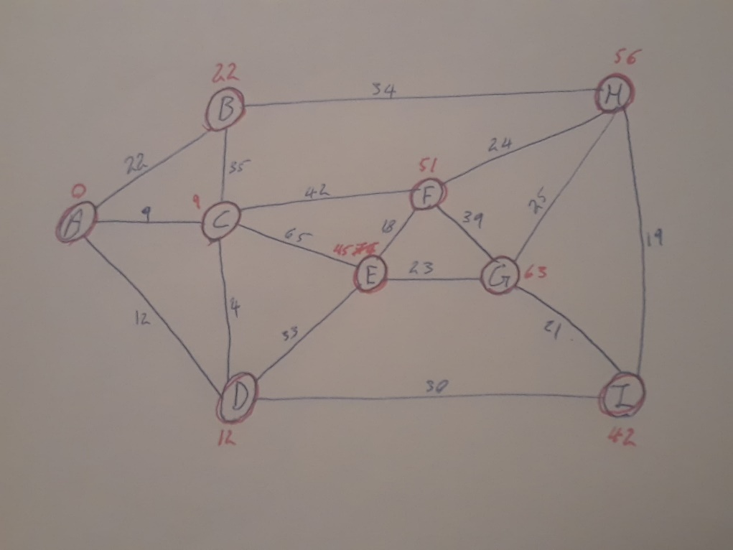

3, Time complexity is O(mlogn).

4,

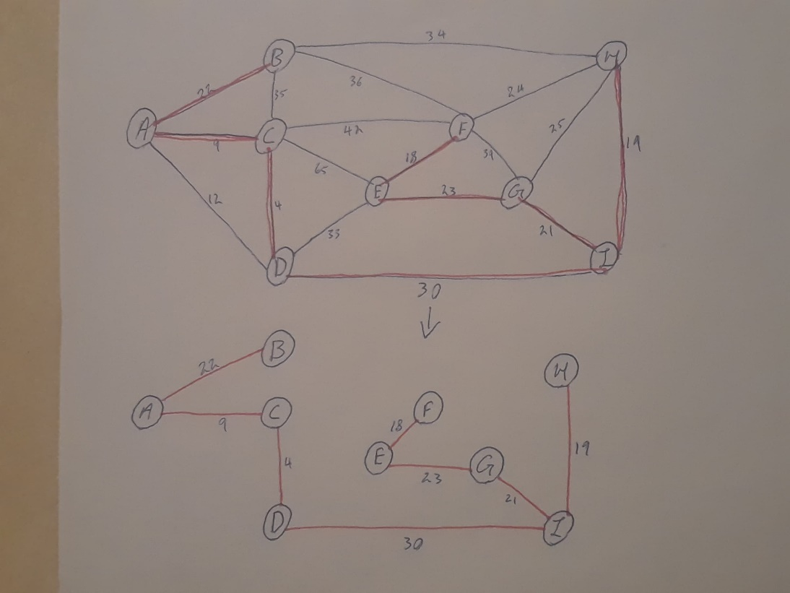

5,Time complexity is O(ElogE) where E is number of edges .

6,

|  |  |  |  |  |  |  |
| --- | --- | --- | --- | --- | --- | --- |
|  | P | Q | T | S | R | U |
| P | 0 | 1 | 7 | 6 | 0 | 0 |
| Q | 0 | 0 | 0 | 4 | 1 | 0 |
| T | 0 | 0 | 0 | 3 | 0 | 2 |
| S | 0 | 0 | 3 | 0 | 2 | 2 |
| R | 0 | 0 | 0 | 2 | 0 | 1 |
| U | 0 | 0 | 0 | 0 | 0 | 0 |

7,

D[P]=0

D[Q]=min{D[p]+ wt(P,Q)|(P,Q) elemnt of E}

=min{0+1}=1

D[R]=min{D[Q]+ wt(Q,R)|( Q,R) elemnt of E}

=min{1+1}=2

D[S]=min{ D[p]+ wt(P,S) , D[Q]+wt(Q,S), D[R]+wt(R,S) | (P,S),(Q,S),( R,S) elemnt of E}

=min{0+6,1+4,2+2}=4

D[T]=min{D[p]+ wt(P,T) , D[S]+wt(S,T) | (S,T) (P,T) elemnt of E}

=min{0+7,4+3}=7

D[U]=min{ D[R]+ wt(R,U) , D[S]+wt(S,U), D[T]+wt(T,U) | (R,U),(S,U),( T,U) elemnt of E}

=min{2+1,4+2,7+2}=3

8.Time complexity is O(m+n) where n is number of nodes and m is number of edges

9.yes by using Dijkstra’s algorithm the shortest path is {(P,Q),(Q,R),(R,U)} which is 3

10,

step 1

A[P]=0

B[P]={}

Put P in X

Step2

X={P}

Find the minimum of the following

d[Q]=d[P]+wt(P,Q)=0+1=1 🡨

d[S]=d[P]+wt(P,S)=0+6=6

d[T]=d[P]+wt(P,T)=0+7=7

Add Q to X

Step 3 X={P,Q}

Find minimum of the following

d[S]= d[P]+wt(P,S)=0+6=6

d[T]=d[P]+wt(P,T)=0+7=7

d[S]=d[Q]+wt(P,S)=1+4=5

d[R]=d[Q]+wt(Q,R)=1+1=2 🡨

Add R to X

Step 4

X={P,Q,R}

Find the minimum of the following

d[S]= d[P]+wt(P,S)=0+6=6

d[S]=d[Q]+wt(P,S)=1+4=5

d[T]=d[P]+wt(P,T)=0+7=7

d[S]=d[R]+wt(R,S)=2+2=4

d[U]=d[R]+wt(R,U)=2+1=3 🡨

Add U to X

X={P,Q,R,U}

The targeted vertex is U so shortest way is P,Q,R,U with length 3.